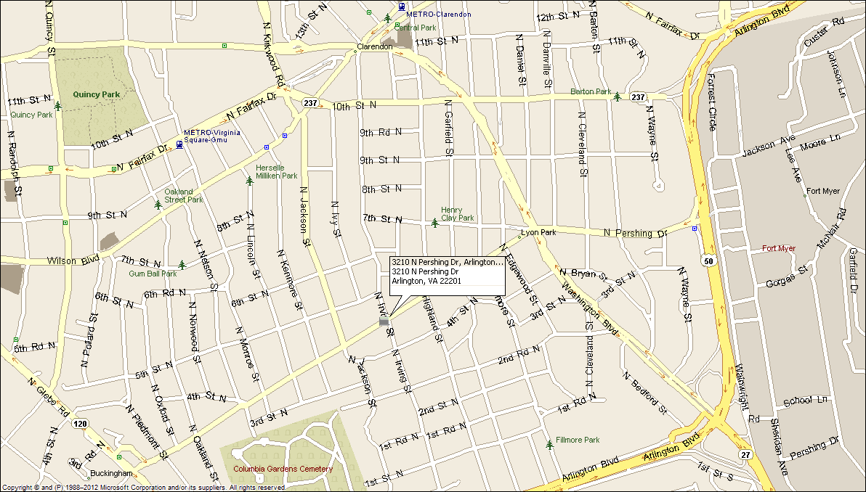
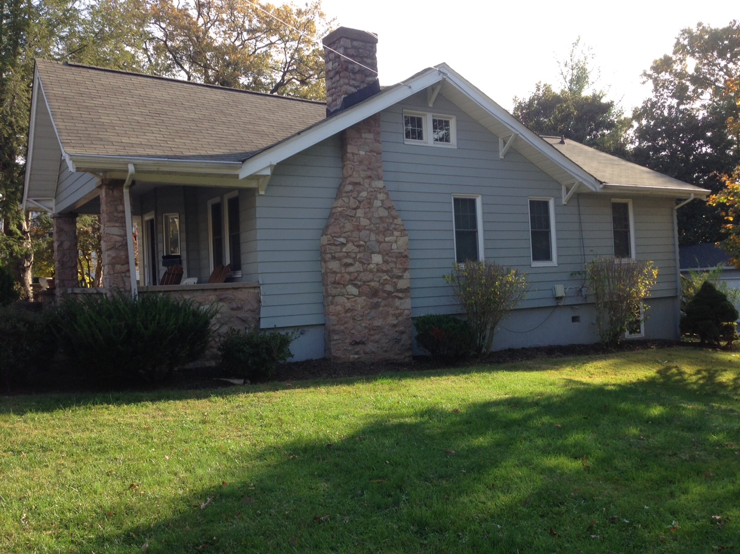
3210 N. Pershing Drive Arlington, VA 22201
Extensively Renovated Large Bungalow, Ashton Heights location
Great location: Walk to VA Square or Clarendon Metro, Close to DC (5 mins), and major commuting routes.
- Four bedrooms, two full baths.
- New kitchen and all new SS appliances, two refrigerators.
- Central a/c, natural gas heat & hot water, New Furnace & AC
- Off street parking for 4 cars.
- Large landscaped fenced yard with back yard fire pit, and new Tiki bar
- Original refinished hardwood floors thru out.
- Established quiet, sought after neighborhood.
- Lease terms: 1 year minimum, no smoking, no use of fire place.
RENT: $3,995.00 / month + utilities, contact Lyndsay Saffer 703-906-3082
Email: safferlyndsay@gmail.com

